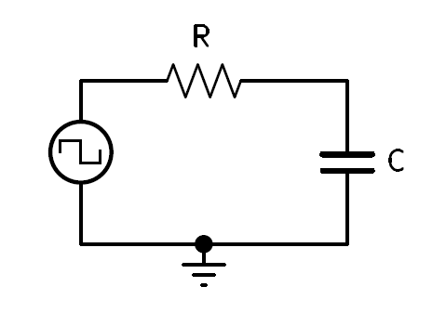Consider the following circuit:

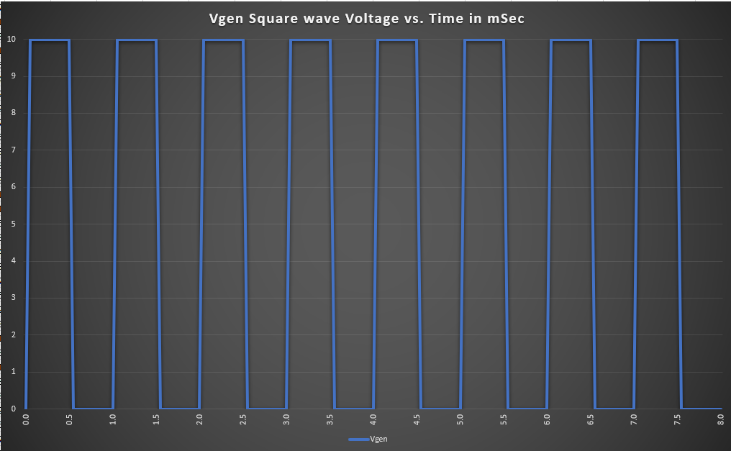Vgen = square wave 50% Duty Cycle

What happens when $t_{on}$ is less than ?

* + #of cycles = 5 $τ$ (stable?)
  + How many cycles for stabilization?
    - If:
 $1 cycle=period$

 $\#of cycles?=5τ$

 $\frac{\#of cycles?}{5τ}= \frac{1 cycle}{Period}$

 $\#of cycles?=\frac{{5τ}_{Sec}}{{Period}_{Sec}}$- *(cycles)*
      * Note, this formula only works on 50% duty cycles square waves.
* If the timeon/off is less than 5 tau the capacitor voltage will not be able to reach or charge up to a voltage equal Vgen, likewise, Vc will not be able to fully discharge during the time off. Additionally, because the Duty Cycle is 50%, the same time on & off time, the Vc waveform will appear to center itself or superimpose itself at an amplitude at the exact vertical center of Vgen.
* Now we know how many cycles it will take for the circuit voltages to stabilize and we know once Vc is stable the capacitor voltage will charge and discharge above and below the average generator voltage (integration).

What voltages will the Vc, charge to (Vmax) and discharge to (Vmin) be?

* Once stable, What voltage will the Vc charge to (Vmax) and discharge to (Vmin)?
$Vc=Vfin -\left(Vfin -Vin\right)e^{\frac{-t}{RC}}$

$Vc=Vmax$

$V{gen}_{+}=Vfin$

$Vin=Vmin$

$Vmin= V{gen}_{+}-Vmax$

$Vin=V{gen}_{+}-Vmax$

$Vmax=V{gen}_{+}-(V{gen}_{+}-(V{gen}_{+}-Vmax))e^{\frac{-t}{RC}}$

$Vmax=V{gen}_{+}-(V{gen}_{+}-V{gen}_{+}+Vmax))e^{\frac{-t}{RC}}$

$Vmax=V{gen}_{+}-(Vmax)e^{\frac{-t}{RC}}$

$Vmax+(Vmax)e^{\frac{-t}{RC}}=V{gen}_{+}$

$Vmax(1+e^{\frac{-t}{RC}})=V{gen}_{+}$

$Vmax=\frac{V{gen}_{+}}{1+e^{\frac{-t}{RC}}}$

* Now that we have Vmax, we can use our previously defined Vmin formula to solve for Vmin.

$Vmin= V{gen}_{+}-Vmax$

Let’s work through a problem and see if our formulas are correct.

Three formulas derived.

* + ***(cycles)*(stabilization)**

$Vmax=\frac{V{gen}_{+}}{1+e^{\frac{-t}{RC}}}$

$Vmin= V{gen}_{+}-Vmax$

If we consider a Square wave 50% DC Vgen is set to operate between 0v to10v @ 1Khz and R = 1KΩ & C = 1µF.

* + (stabilization)
    - $\#of cycles$ = 5 cycles (stabilization)
  + $Vmax=\frac{V{gen}_{+}}{1+e^{\frac{-t}{RC}}}$ = $\frac{10v_{+}}{1+e^{\frac{-500μsec}{1K×1µF}}}$ = $\frac{10v}{1+ .606531}$
 $Vmax=$ $6.225vp$

$Vmin= V{gen}_{+}-Vmax$ + = $10vp-6.225vp$
    - $Vmin$**= $3.775vp$**
* Additionally, we can check our work by taking the average voltage between Vmax and Vmin. We know that the waveform should be centered around the average Vgen voltage, in this case 10v/2 = 5v.
* $Vavg=\frac{Vmax+Vmin}{2}$ = $\frac{6.225+3.775}{2}$ = $\frac{10}{2}=5v$

What happens when $t_{on}$ is less than $5τ$?

If the generator is set to 0 to 10v @ 1Khz and R = 1KΩ and C = 1µF

* (stabilization) $\#of cycles$ = 5 cycles, $Vmax=$ $6.225vp$& $Vmin$ = $3.775vp$

Using Capacitor Charge Formula:

$Vc=3.935v_{(t=0.5msec)}$

$Vc=2.387v_{(t=1msec)}$

$Vc=5.382v_{(t=1.5msec)}$

$Vc=3.265v_{(t=2msec)}$

$Vc=5.915v_{(t=2.5msec)}$

$Vc=3.587v_{(t=3msec)}$

$Vc=6.111v_{(t=3.5msec)}$

$Vc=3.706v_{(t=4msec)}$

$Vc=6.182v_{(t=4.5msec)}$

$Vc=3.74v_{(t=5msec)}$

$Vc=6.209v_{(t=5.5msec)}$

$Vc=3.766v_{(t=6msec)}$

$Vc=6.219v_{(t=6.5msec)}$

$Vc=3.772v_{(t=7msec)}$

$Vc=6.223v_{(t=7.5msec)}$

$Vc=3.774v_{(t=8msec)}$

